

**PB STATCLEAN SOLUTIONS PVT LTD**

**INTRODUCING COVID-19 PROTECTION PRODUCTS**

**Prop. No. 1A, First Floor, Shiv Mandir Mohalla, Badli Chowk, Delhi – 110042**

**(Near NCC Bhawan & Above Pancham Sweets)**

**PPE KITs**

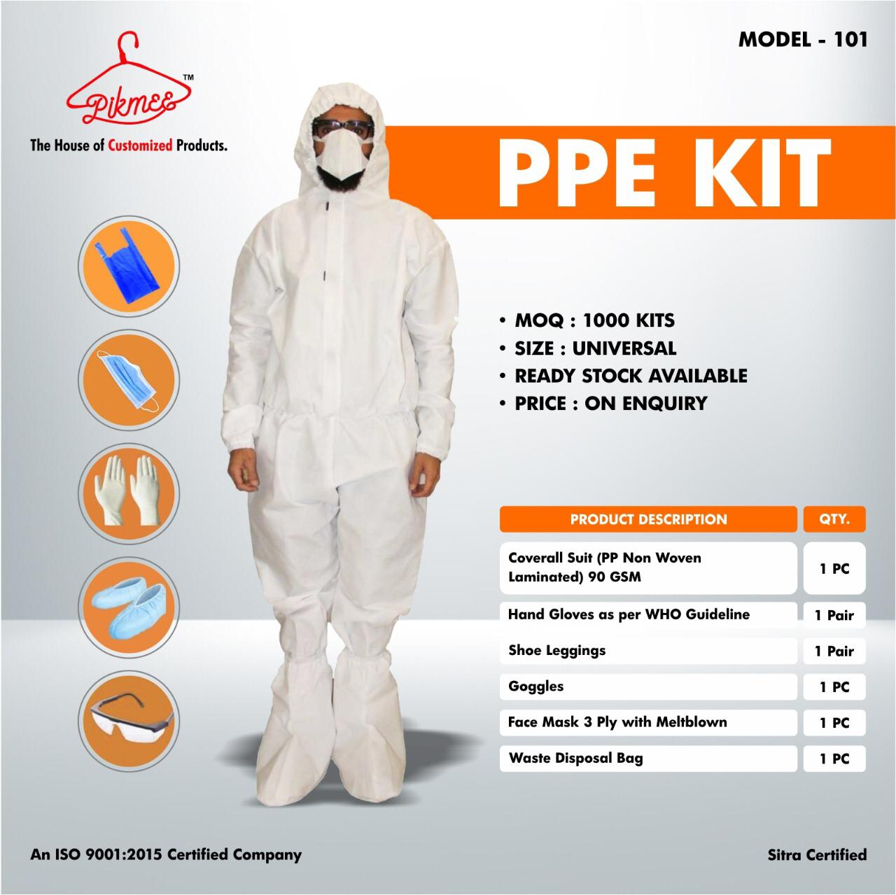

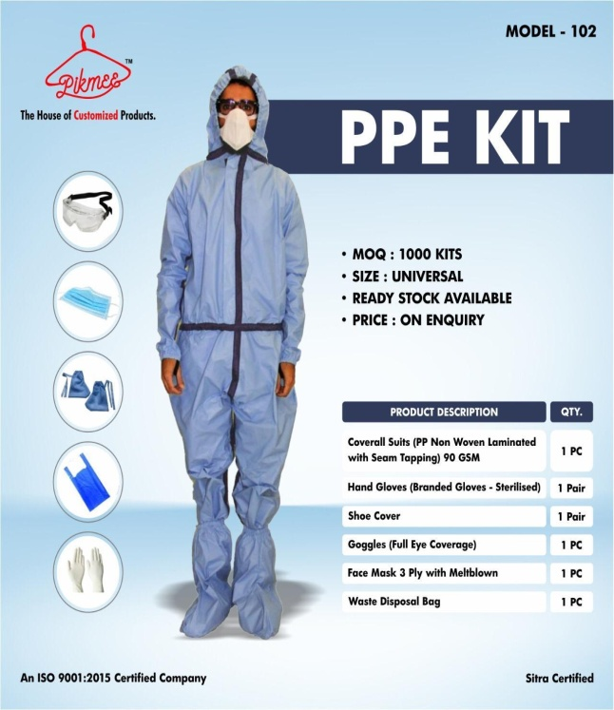

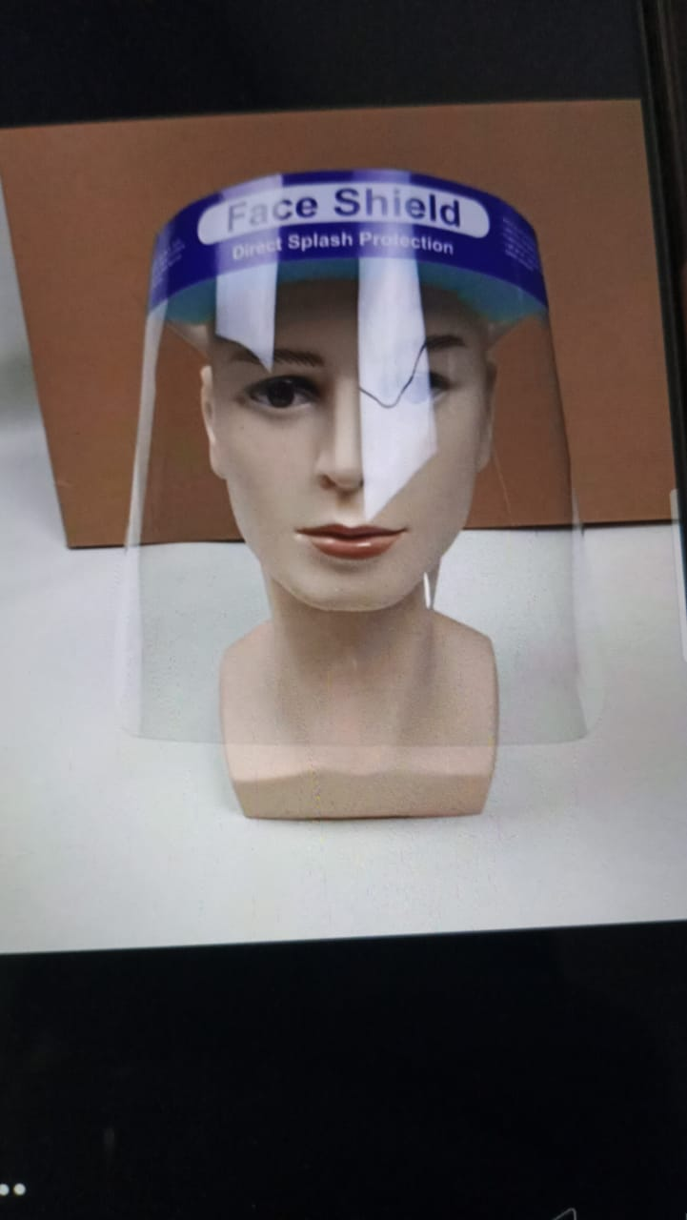

**FACE SHIELD**

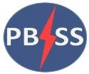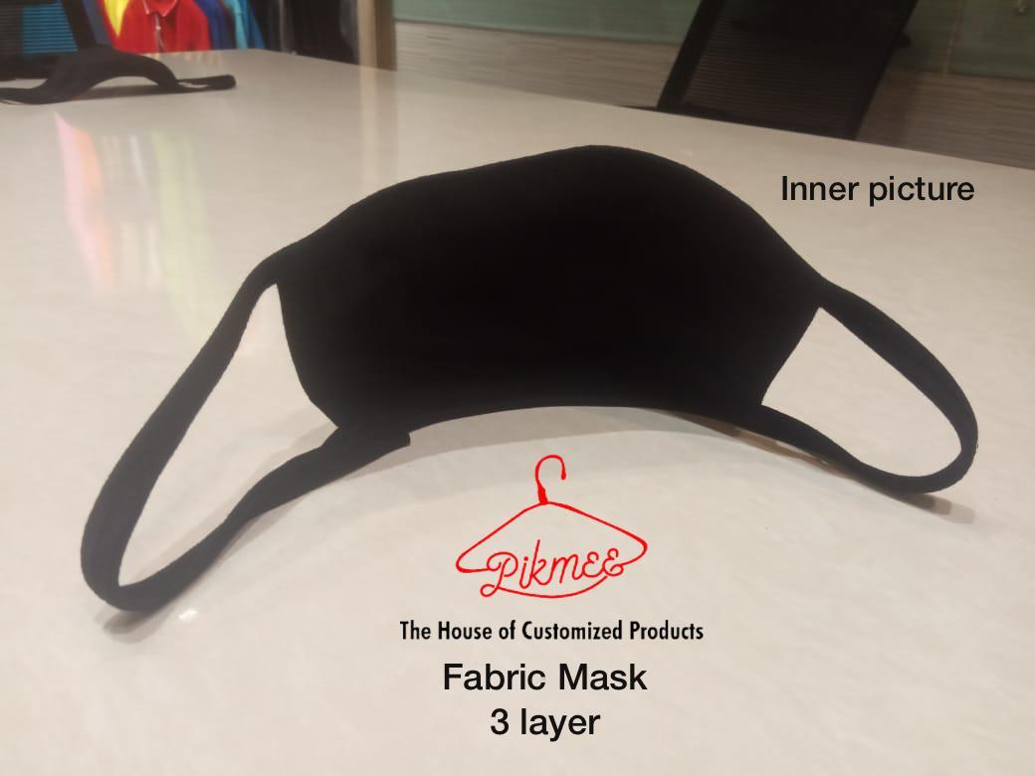

**WASHABLE FACE MASK**

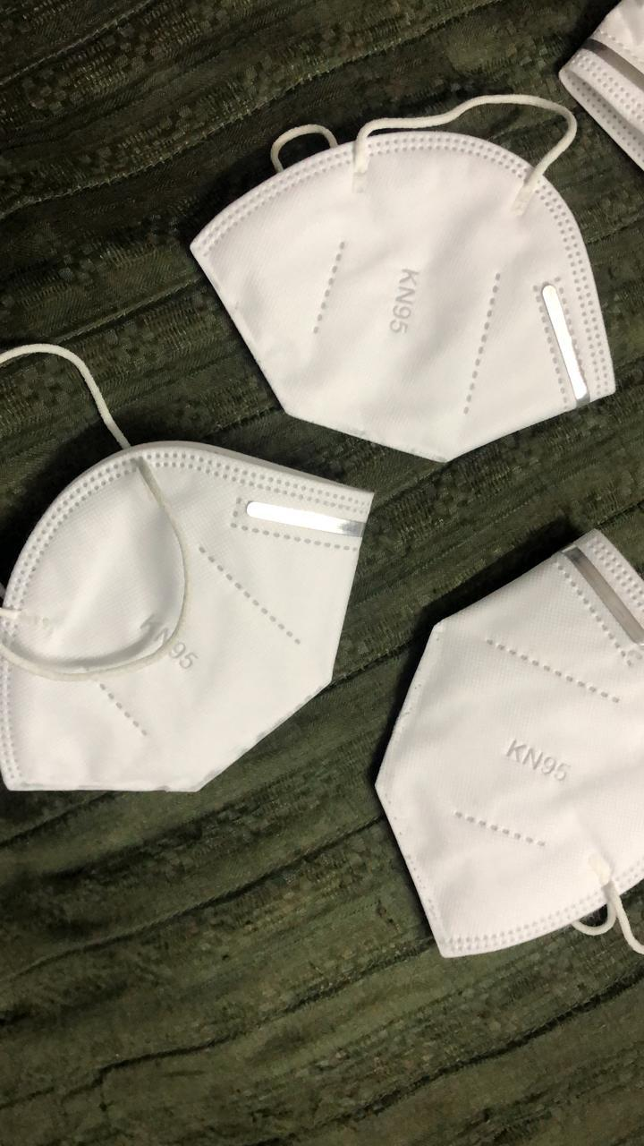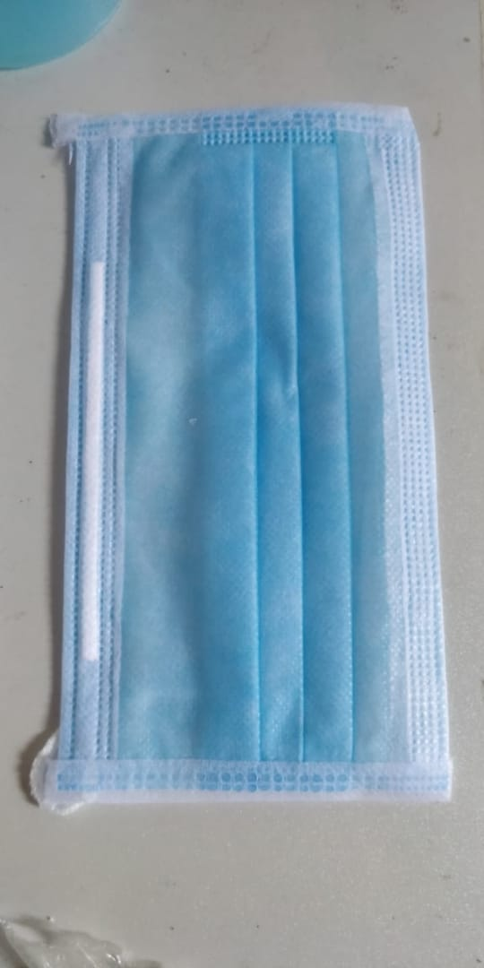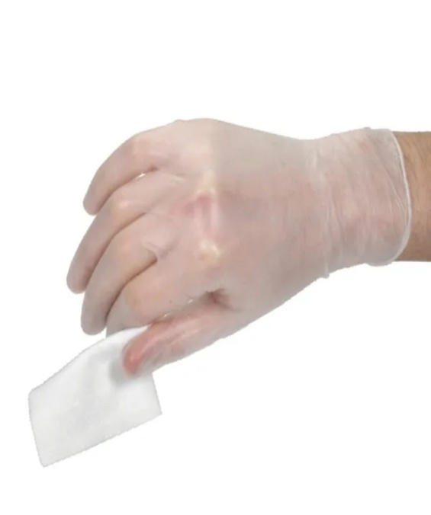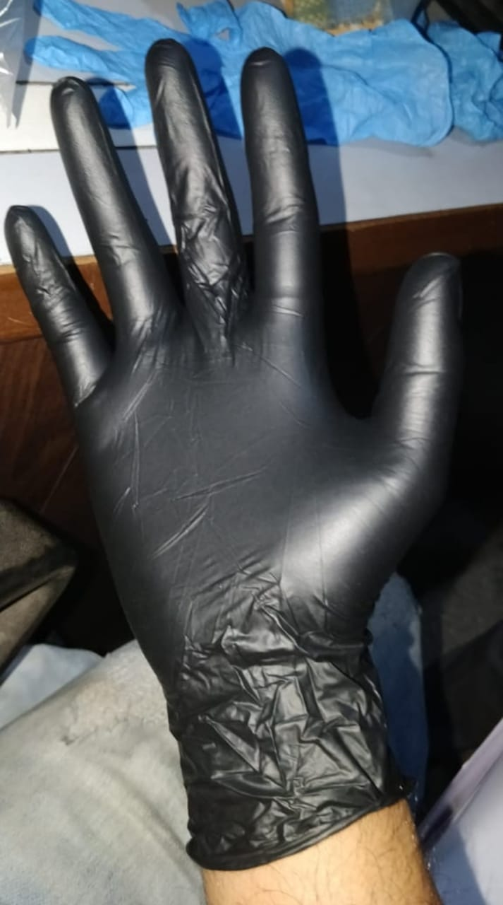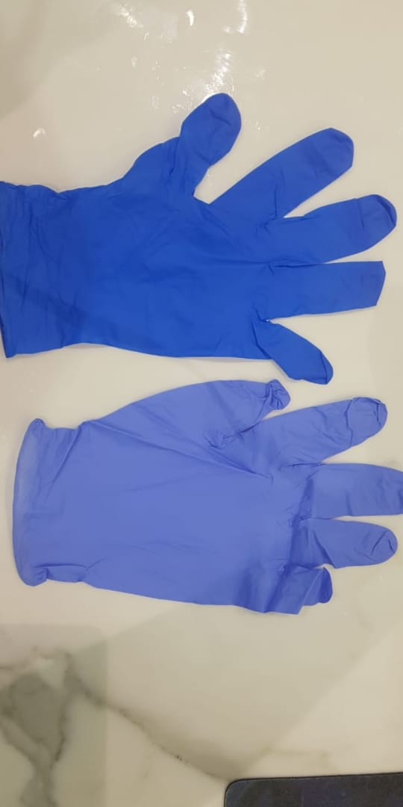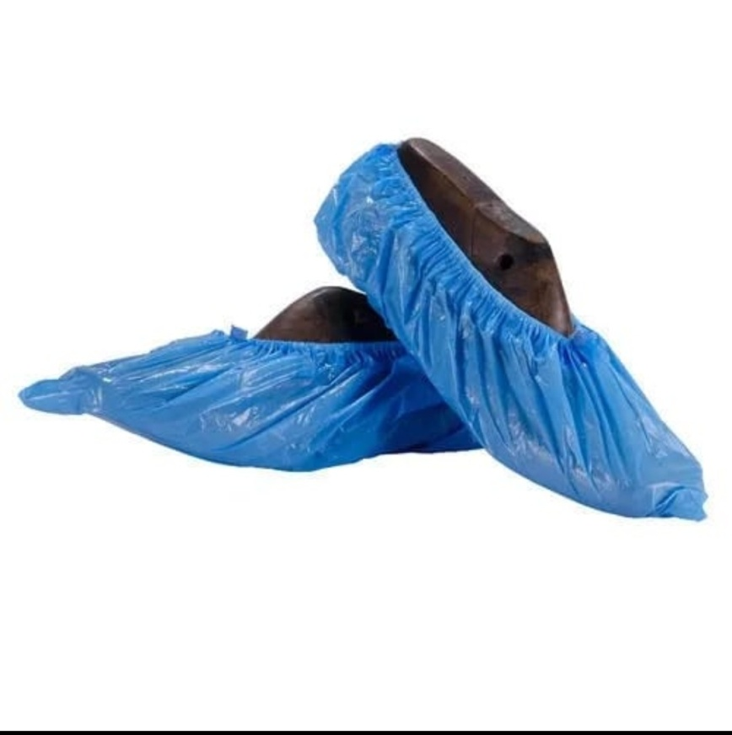

**DISPOSABLE FACE MASK**

**KN95 FACE MASK**

**DISPOSABLE GLOVES**

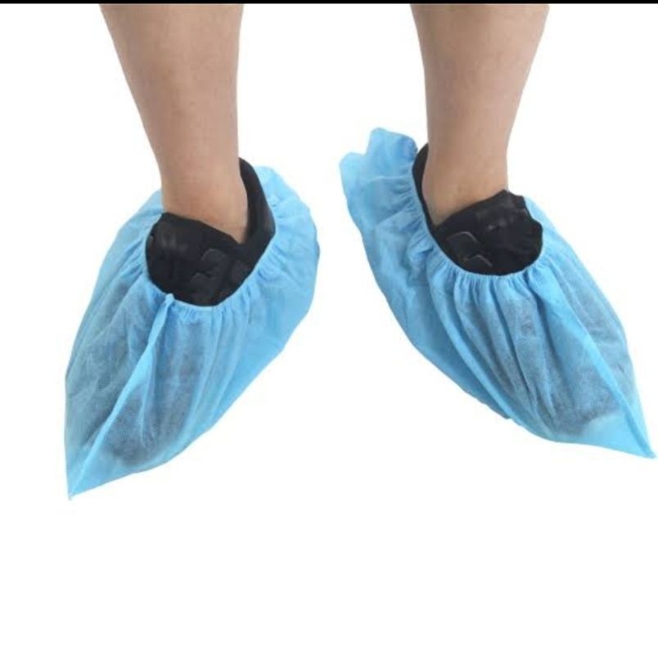

**DISPOSABLE SHOE COVERS**

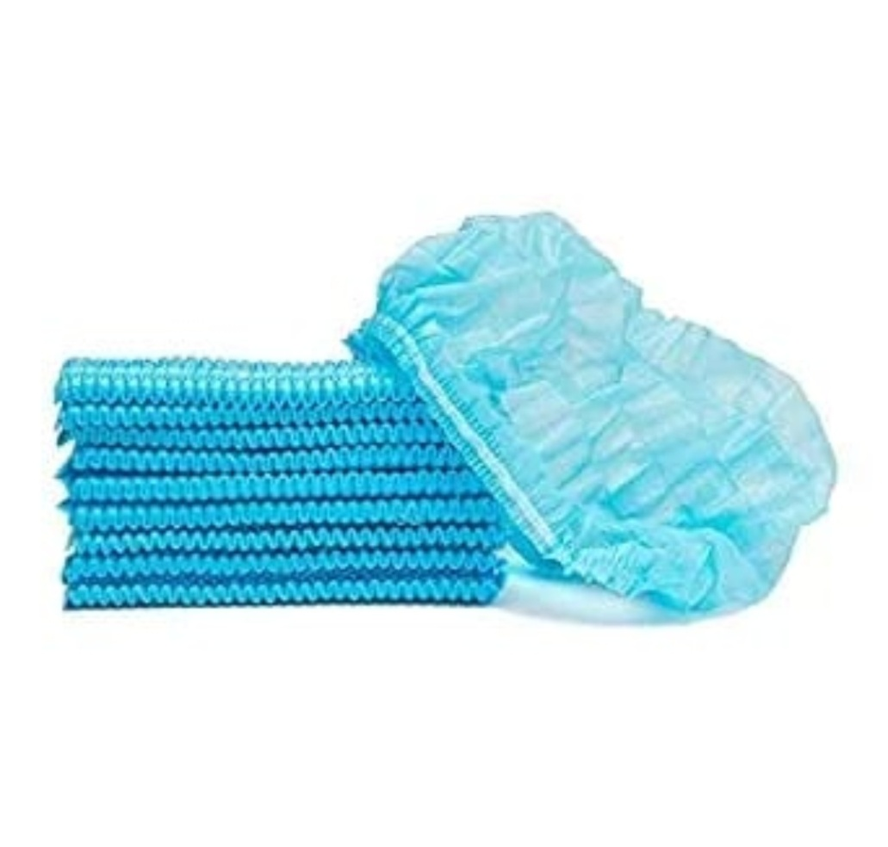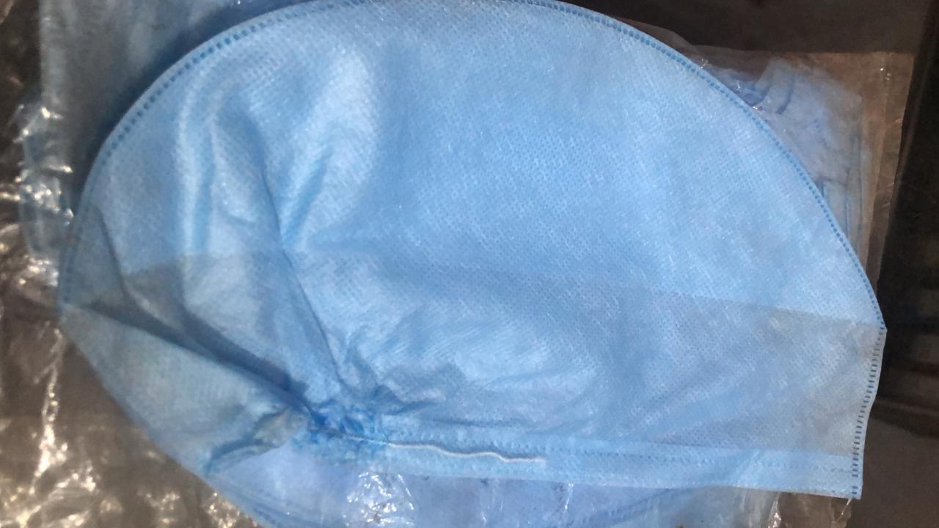

**DISPOSABLE HEAD CAPS**

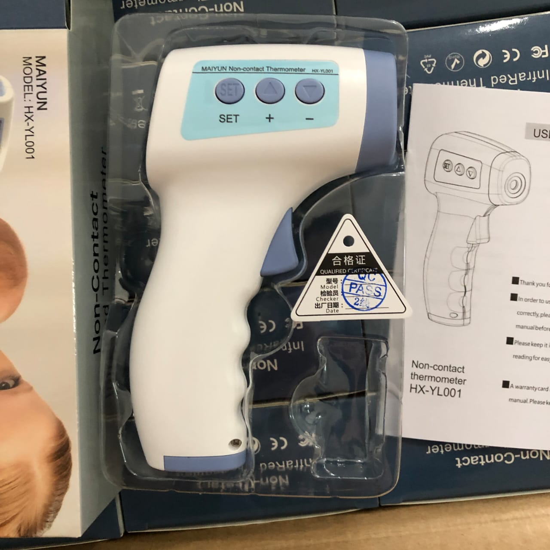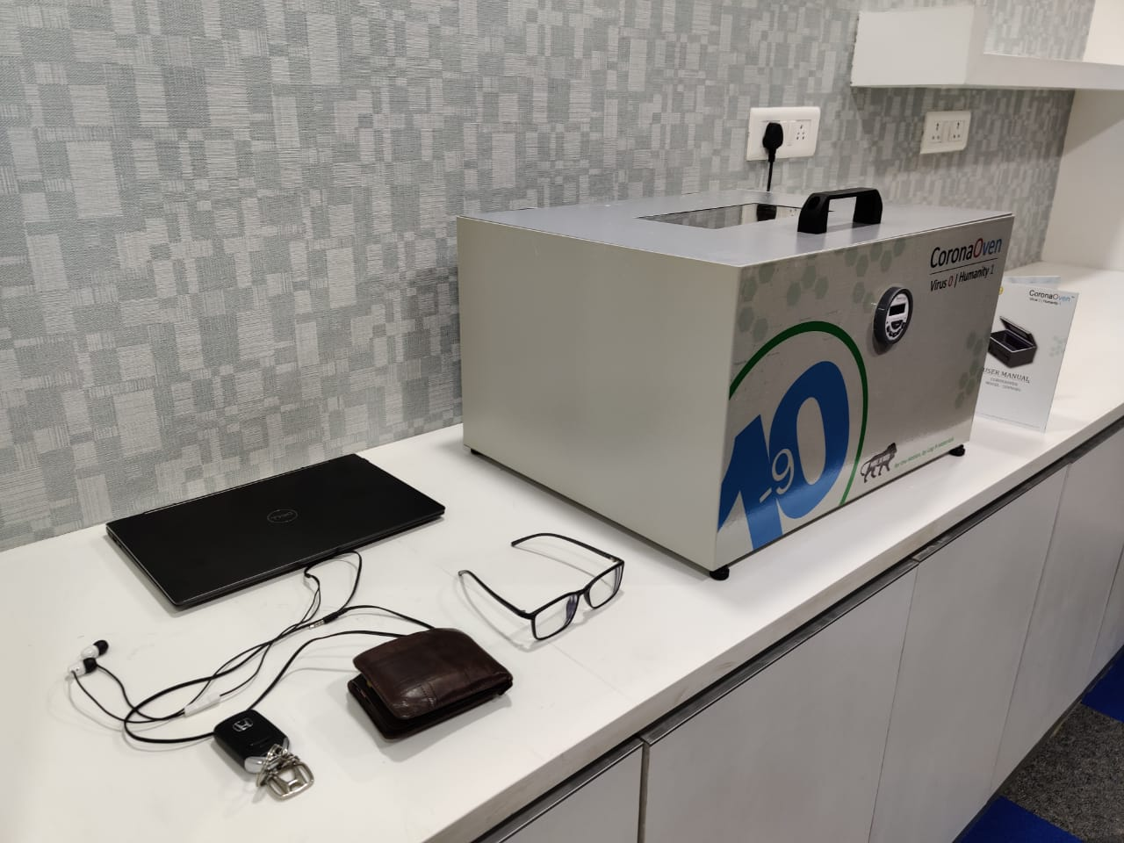

**IR THERMOMETER**

**PORTABLE UV DISINFECTION CHAMBER**

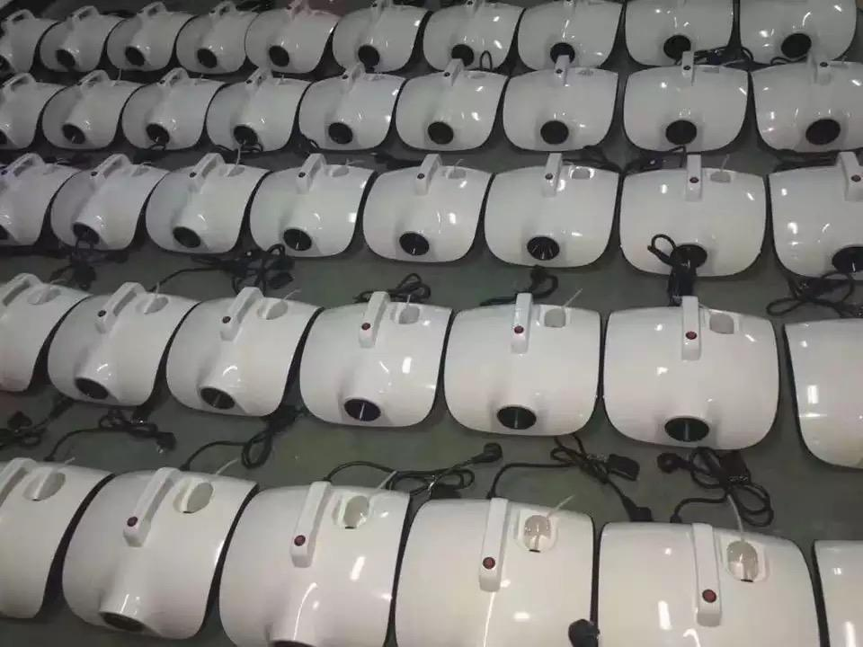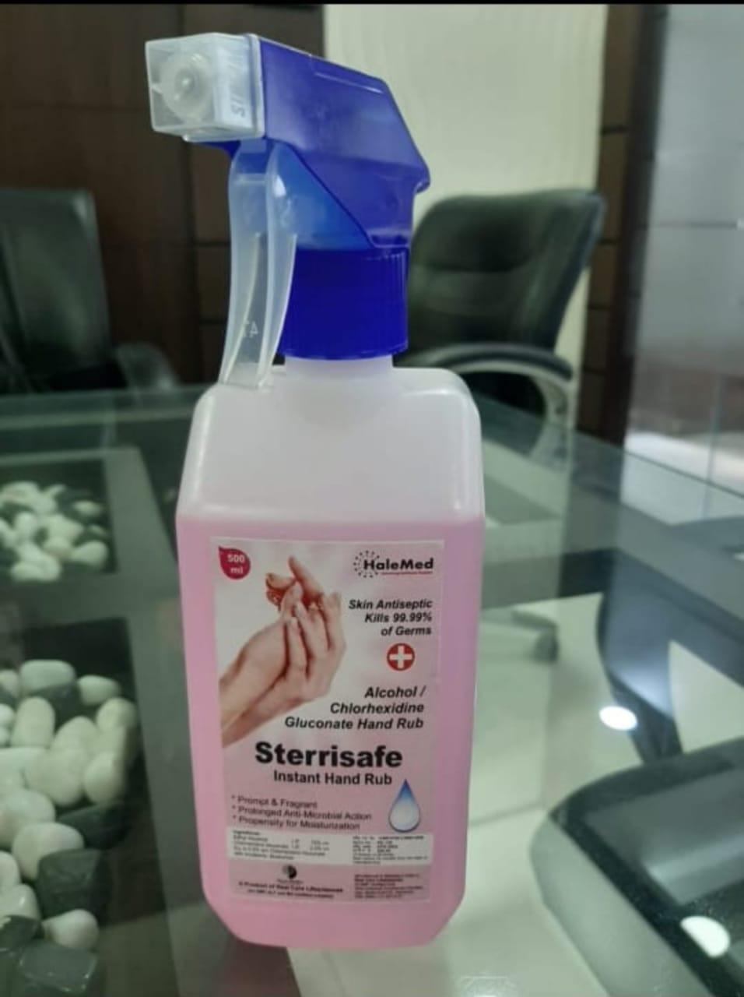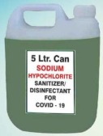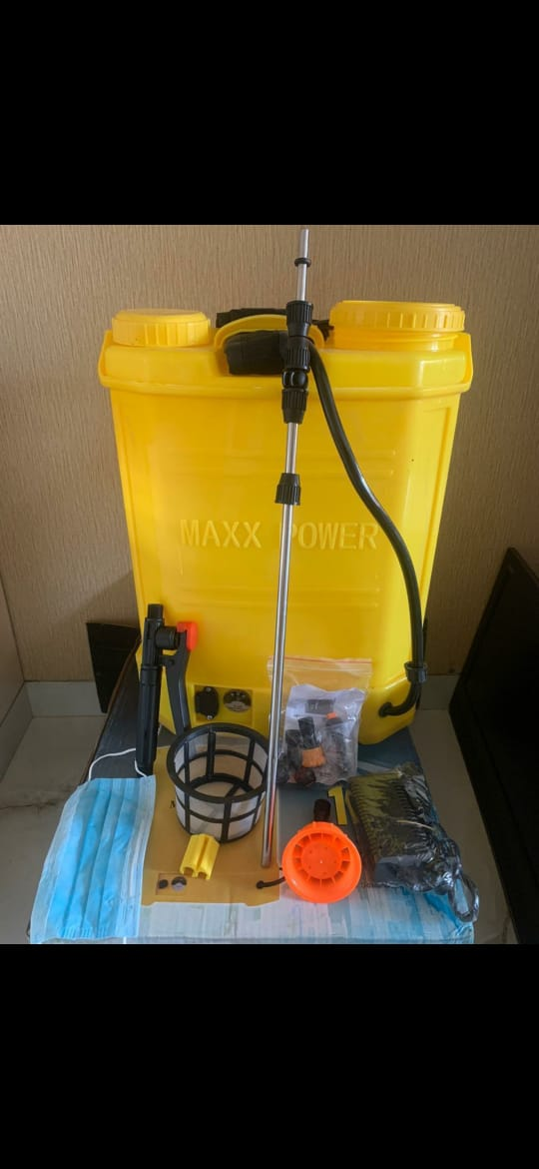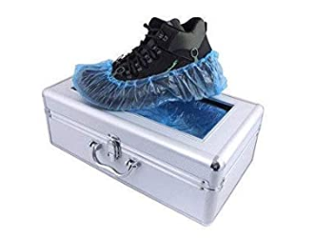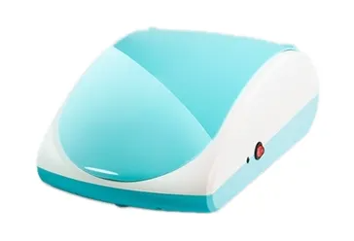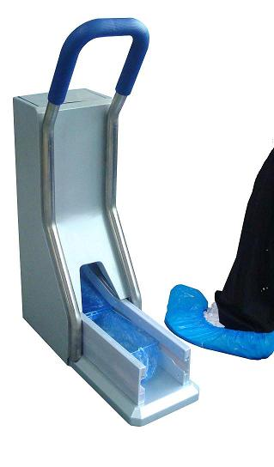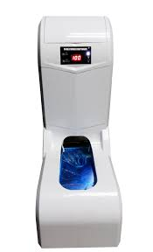

**ATOMIC SANITIZER**

**OR**

**FOGGING MACHINE**

**BODY & OBJECT SANITIZERs**

**BATTERY TYPE SPRAYER**

**SHOE COVER DISPENSER**

**SHOE COVER DISPENSER**

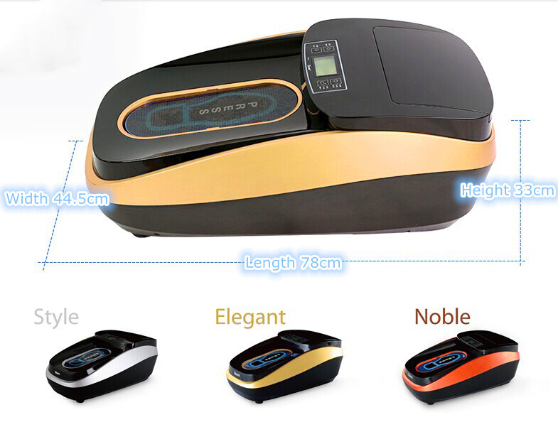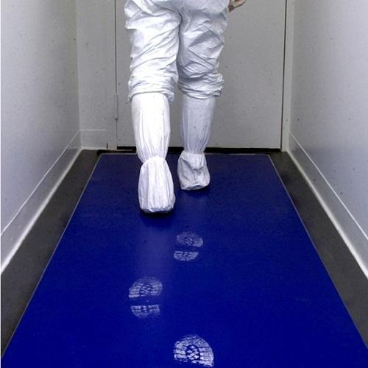

**ADVANCED**

**SHOE WRAPPING MACHINE**

**STICKY MAT**